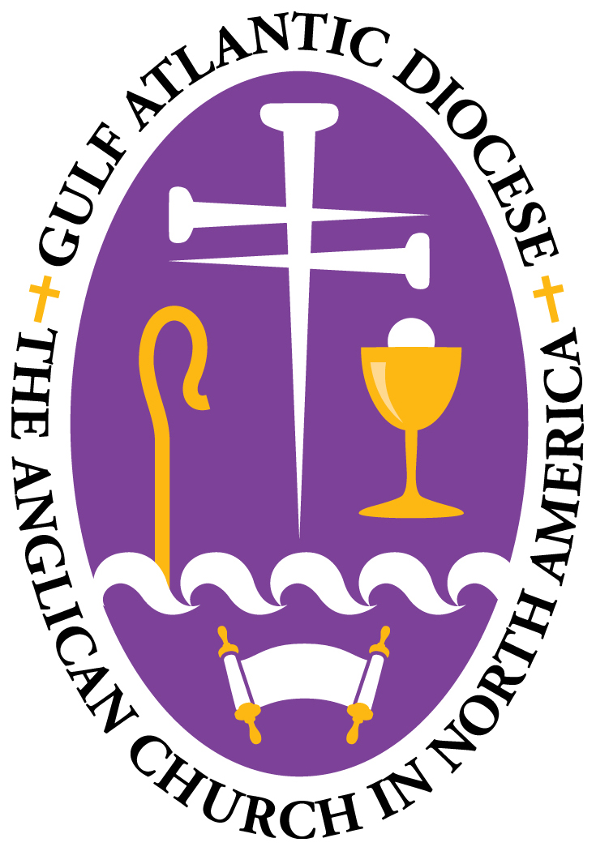

In the Name of the Father,
and of the Son,
and of the Holy Spirit. Amen.

DECLARATION OF INTENTION

We

and

desiring to receive the blessing of Holy Matrimony in the Church, do solemnly declare that we hold marriage to be a lifelong union of husband and wife as it is set forth in the Book of Common Prayer.

We believe it is for the purpose of the procreation (if it may be) of children, and their spiritual and physical nurture, for mutual fellowship, encouragement, and understanding, and for the safeguarding and benefit of society, and we do engage ourselves, so far as in us lies, to make our utmost effort to establish this relationship and to seek God’s help thereto.

Signature of Groom

Signature of Bride (Maiden Name)

Date

